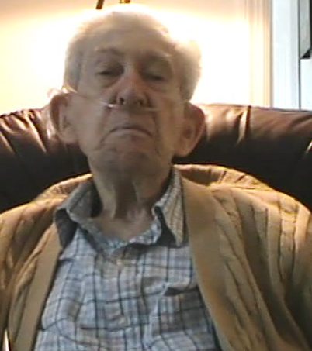
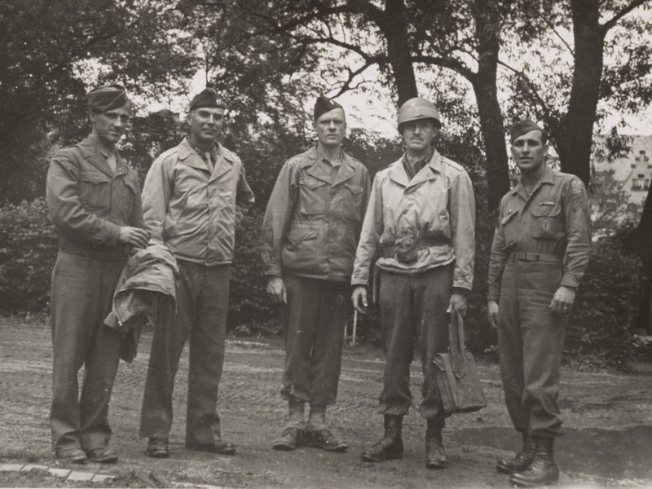
HORANCE “HAP” APGAR
100th DIVISION SOLDIER
&
MONUMENT'S MAN

BASIC TRAINING
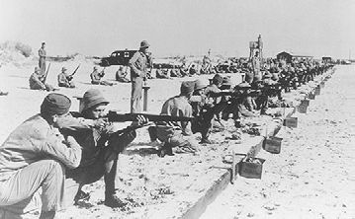
“My freshman year of college in 1943 I signed up to join the military after the school year was over. I was called into Indian Town, an army summer camp they collected the recruits and sent them to Fort McClellen in Alabama. From there I was sent to Fort Brag, when I left Fort Brag he was a Private. Training included walking up into the mountains in the morning rest included lunch, lots of Ice it was not easy but there was no mistreatment we did what they had to do most of the recruits had done small game shooting, it seemed like they had a lot of farmers. I had some work to do and I knew it was for my own survival.”

FIGHTING IN FRANCE
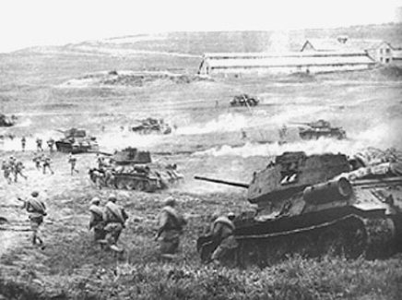
“The little towns I saw with Narrow roads, the countryside towns. There was a fortress on top of a hill held by the Germans I was fighting on the same lines as the major battle happening at the time. The hillside was a shooting gallery we had a lot of wounded however these men would have to remain overseas because of the point system. A man in 2nd battalion was not too happy about that He did not leave the front even after taking a shot of Shrapnal to the helmet, gave them a reason to place a top on the Foxhole. The weather, it was cold for some time during the days in France.”
BEING A MONUMENT MAN
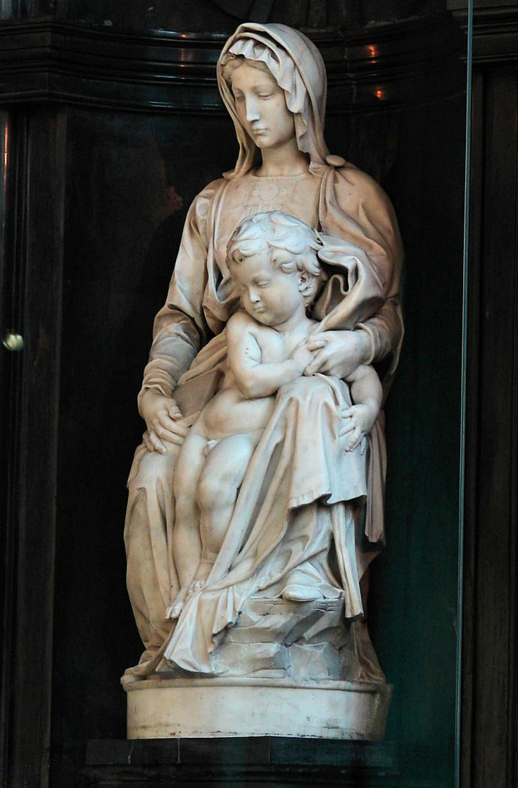
“After the Shooting stoped After VJ Day, I needed enough points to leave for home, and I did not have enough points so I needed stay. I went Germany, one mission was to take a GI car to a POW camp I was told they had assignment in Frankfurt, having to transport prisoners. Monument's men were was in Frankfurt at the time and I was a Sergent, I worked his way up then we went for the St. Peter Statue and Two lesser works there as well, they were whitish stone statues. There was mile of rock the put around them and they were wide and a 15 feet high, and this statue was inside a building.”

RETELLING THE STORY
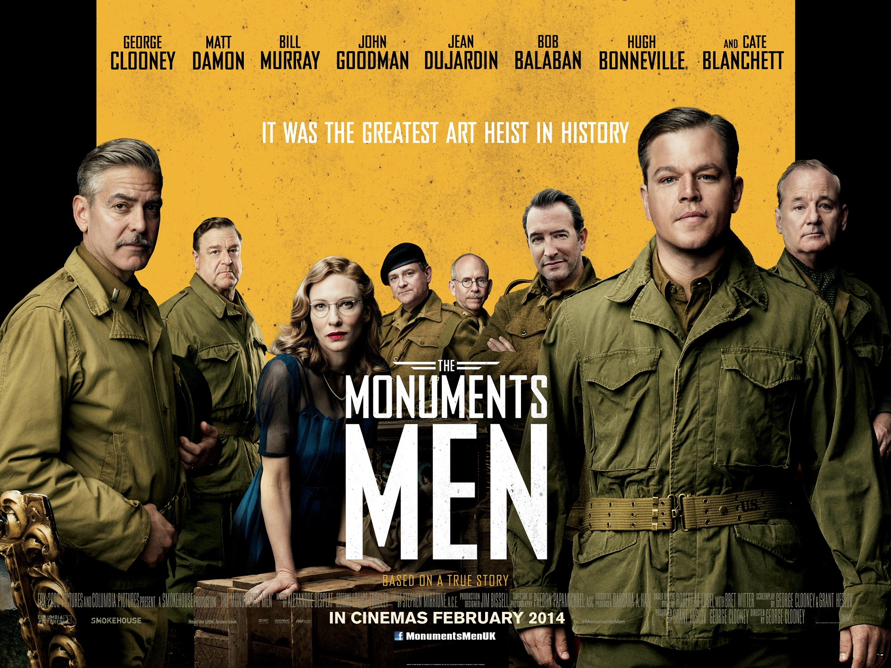
“The first time I saw the movie was at my home town, there were four other people in the theater at the time. One couple was an acquantence but the other people thanked him of serving in the war. I got a good view of the movie, the people could care less, It's following the murder news Story, But I had experience in Combat where others did not.”

POST WAR REACTIONS
“I won the Bronze Star and Combat Infantryman's Badge, returning property to the right hands gave me satisfaction. I even saw notebooks about German spoils, they developed color photogrpahy so there was a color picture of the item and who owned it and where they lived all in all I was very fortunate in the war.”

